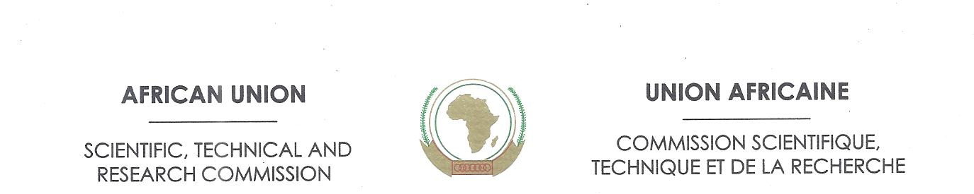

_____________________________________________________________

African Union Scientific, Technical and Research Commission

(AU/STRC)
Abuja, Nigeria

Progress Report of STRC Activities for 2016

African Union Scientific, Technical and Research Commission

The Scientific, Technical and Research Commission of the African Union (STRC) as a specialized institution of the African Union based in Abuja, Nigeria is mandated to implement projects and programmes that are guided by the STISA 2024 and its predecessor CPA. It is also mandated to participate actively in the implementation of other AU development strategies and policies. As of this reporting period a considerable progress has been made in the implementation STISA 2024:

- Programme implementation

- African Union Network of Sciences,
- Africa’s STI challenges and climate change
- Establishment of Pan African Institutions [African Scientific Research and Innovation Council (ASRIC) and Pan African Intellectual Property Organization (PAIPO)]
- Africa Health Research Capacity

- African Union Network of Sciences (AUNS); phase 2 Mobilizing Technical and Financial Support for the Network Lauching

The STISA 2024 second pillar of building technical and professional competencies and third priority area of communication (physical and intellectual mobility) called for this project and was developed to impact on the continent. The African Union Network on Sciences is a virtual network that involves a wide range of individuals/institutions working together to address Africa’s scientific and technological development challenges. It is a platform where African Scientist, Engineers, Innovators, Inventors and Technology developers will be able to interact, cooperate, exchange information/knowledge and complement one another in research and academic work. It is also an innovative way to enhance brain circulation and bridge the African based Scientists and those in the Diaspora to address Africa’s Challenges and the project is to be implemented in four phases.

This network received applaud and commendation from TWAS, The African Academy of Sciences, The Bibliotheca Alexandria, African Development Bank, UNESCO, GIZ among others.

The STRC was able to convene two meetings so as to garner support and mobilize resources for the project. The first was held on the 5th May, 2016 with the host country Nigeria where all key stakeholders the Ministry of Communication Technology, Ministry of Science and Technology, Nigerian Communication Commission, Nigerian Information Technology Development Agency, and the Ministry of Foreign Affairs participated. The meeting applauded the project with commitment of support to the project and request that the end-users be involved at the beginning of the project. The STRC was informed that the Agencies present at the meeting have the capabilities to assist in the projects and recommended that the concept be presented to the Minister of Communication Technology for further political support and commitment. A bilateral meeting was held on 22nd June, 2016 between the STRC and H.E Adebayo Abdurahman Shittu, the Minister of Communication Technology. The meeting resulted in setting up a Task Force on the implementation of the AUNS.

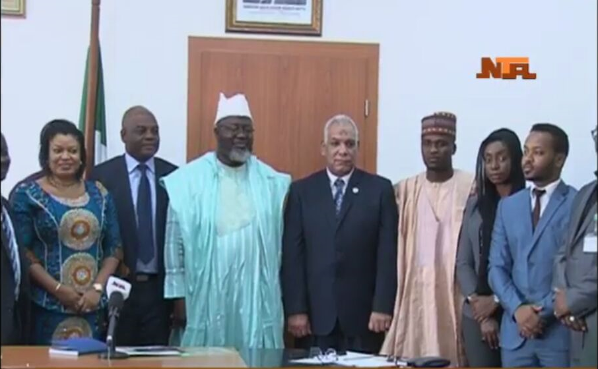
Picture: 3rd from left is H.E Adebayo Shittu and next to him is Dr. Ahmed Hamdy

The Term of Reference (ToR) for the Task Force was developed jointly for the implementation and meetings are on ongoing.

The meeting with the partners and private sector was also held on 16th May, 2016, the concept and the rationale were applauded by all the partners and the brilliance of the idea of the Network. The partners also commended the robust sustainability of the network and promised to unveil their data base to the network, particularly UNESCO is part of a lot of Networks in Africa and that it will be a part of the AUNS. There is the Council of Vice Chancellors and Dean of Engineering Faculties COVISET, African Council of Science and Engineering (Einstein), Network of Environmental Science, Network of Biotechnology among others were set up in partnership with UNESCO and UNESCO is ready to come on board to assist the AUNS at the implementation stage. The partners also promised that their platforms may be used to publicize the AUNS and it can benefit the project the world.

The STRC had a meeting with the MTN Nigeria on the 13th July, 2016 and a presentation of the AUNS was made to the management of the company. The company appreciated and commended the project and requested for;
- The technical feasibility, contextual appropriateness, proposed timeline and budgetary cost effectiveness for the AUNS network portal;
- The capacity building and marketing and promotion measures for the self-sustenance of the network portal; and
- The overall sustainability of the proposed portal in terms of the anticipated results and impact.
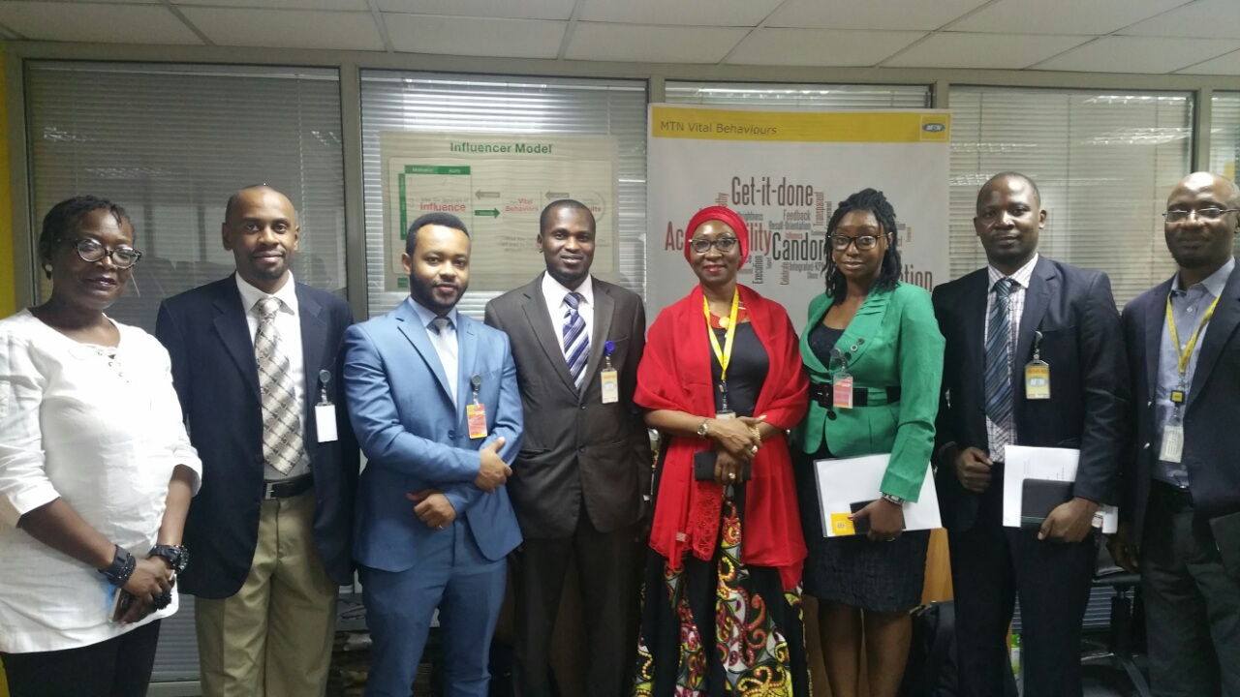
Picture: 4th from left in red is Mrs Amina Oyagbola, Corporate Head MTN Nigeria

In furtherance, to this the STRC has engaged the services of Federation of African Engineering Organization and MBS Engineering to develop the needs for onward transmission to partners and other stakeholder for sponsorship while data collection of prospective users are being done continuously by the office, so far, over 3000 data of prospective members were received.

- Africa’s STI challenges and Climate Change

In line with the STISA 2024 priority of live together-build the society is envisaged to developed programmes that offers solutions to climate change challenges. This is a continuing project that analyses the Africa’s challenges on climate change impact. The second on the series of this study is the ‘Climate Change Impact in Africa: Challenges and Opportunities within the Realm of Science, Technology and Innovation’. This study was commissioned by STRC based on what science and technology can offer to tame the impact of climate change in Africa and was carried out based on reviews of other research work done out by experts.

The analysis was done and submitted to the Nigerian Environmental Society for further review and editing before final publication.

- Establishment of Pan African Institutions [African Scientific Research and Innovation Council (ASRIC) and Pan African Intellectual Property Organization (PAIPO)]

With the strategy of STISA 2024 this programme falls under all the pillars and cut across few priority areas. On establishment of the pan African institutions both the Statute of (ASRIC) and (PAIPO) were endorsed by the 26th Ordinary Session of AU Heads of States and Government in January, 2016. Massive publicity was made on the ASRIC and PAIPO informing Member States and Partners on the endorsement of the Statutes and on the need to launch the respective institutes.

The STRC and the Department have sent out communication to Member States on the Article 23 of the PAIPO Statute calling for signature, ratification and accession.

- Africa Health Research Capacity

The India Africa Health Sciences Meet was held in New Delhi, India from 1st - 3rd September, 2016 and several Africa’s Ministers of Health and dignitaries where in attendance. The STRC presented a paper on ‘’Policy Environment and Mechanisms to Support Health and Pharmaceutical Sector by Utilizing Science Technology and Innovation through Research Translation’’. The meeting discussion was centred on sharing experiences and best practices in the areas of health and pharmaceutical development in Africa considering the commonalities in development pathways between the Indian sub-continent and Africa. There were discussions on the heterogeneous nature of Africa and peculiar needs of Member States ranging from economy and technical capabilities in health related fields.

The meeting recognized the India-Africa joint action plan 2014-2018 where the health sciences need to be integral part of the action. At the margin of the India Africa Health Sciences Meet a bilateral meeting was held with the trio of Indian Council of Medical Research, Welcome Trust and USAID they all welcomed the initiatives of UNESCO-Merck-AU on health capacity building and called for participation of the trio in the forthcoming Summit in Addis Ababa, Ethiopia from 28th – 29th November, 2016 to further see the possibility of how they will assist.
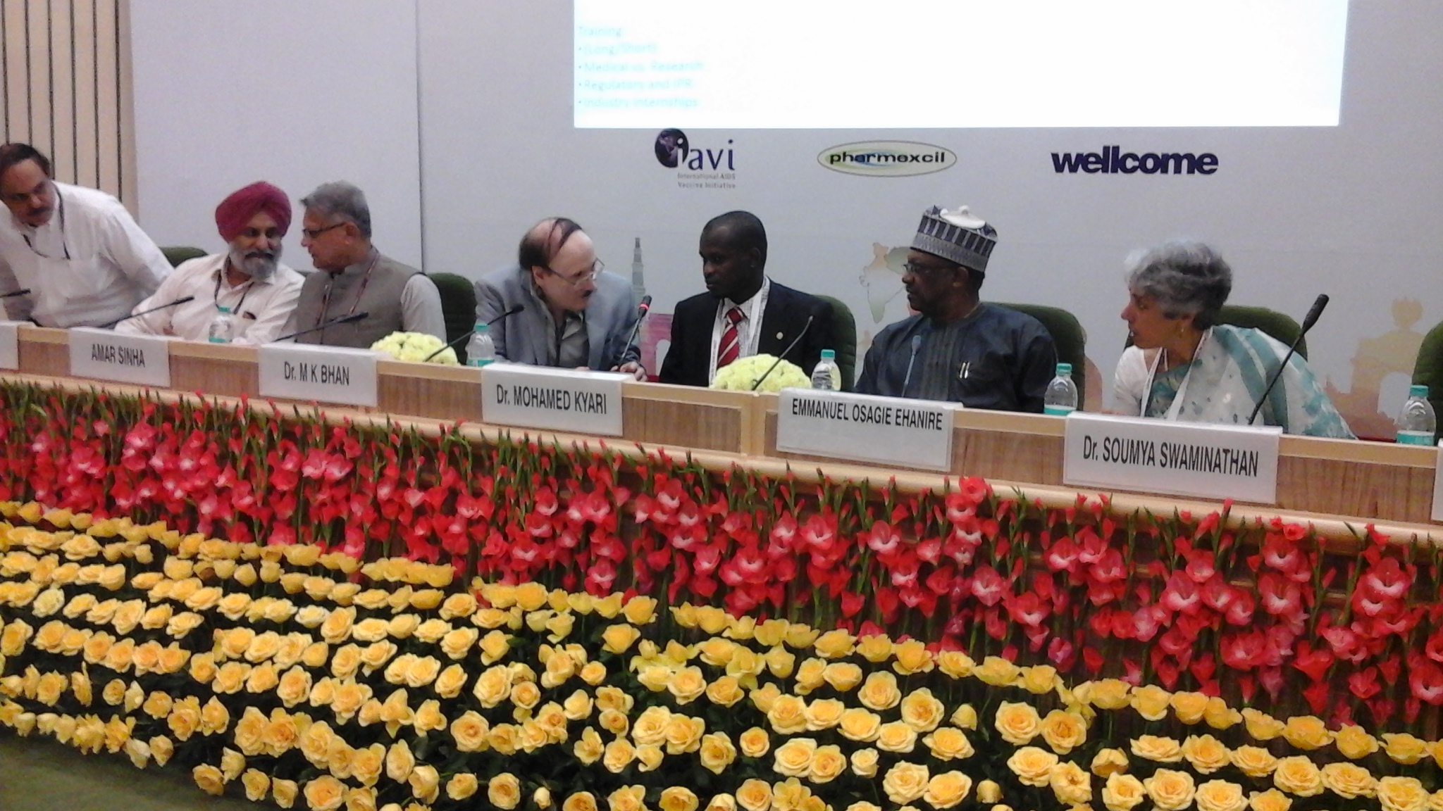
Picture: 2nd from right H.E Dr. Emmanuel Osage Ehanre, Nigeria Minister of State for Health, Dr. Kyari Mohammed and Indian Representatives

As a follow up to the Africa India Health Sciences Meeting, the STRC is working under the framework of India Africa partnership in consultation with the Nigeria Ministry of Health to develop projects and programmes on capacity building for health researchers and medical practitioners for the ECOWAS region. The conceptual framework is to be presented in due course to other African Regions to develop a common Africa position.
The STRC, UNESCO and Merck International organized the 1st STR, UNESCO, MARS Research Summit that was held in Switzerland, Geneva from 19th - 20th October, 2015. It provided a valuable opportunity for all those engaged and interested in scientific research in Africa to learn about the full spectrum of ground breaking research currently underway, and prepare for the road ahead in Africa’s development as an international hub for research excellence and scientific innovation. The Summit attracted over 100 scientists in the field of health sciences and some were awarded for excellence in research work. The first researchers were awarded with Merck R&D fellowship Award for 6 month fellowship in Merck laboratory in Bonn, Germany. The second awardee was rewarded with 1500euro, third with 1000euro, fourth with 700euro, fifth with 500euro and sixth with 300euro. Certificates were given to the rest who participated.

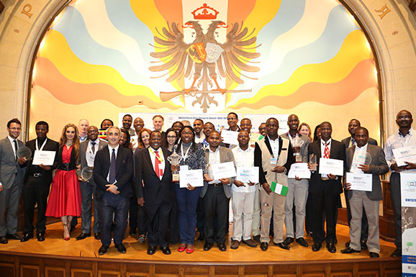
Picture of awardees and participants at the 1st STRC, UNESCO MARS Summit

The 2nd MARS Summit is been organized by the trio from 28 to 29 of November 2016 in Ethiopia, Addis Ababa with a theme; Infectious Disease and Woman Health. The Summit will be showcased by keynote addresses, panel discussion, posters display and launching of the best African woman researcher award on health this is to recognize outstanding contribution of women researchers/scientists with the aim to promote STEM. There will be bilateral discussion at the margin of the Summit to bring on board Merck for the India Africa Health Sciences capacity building platform.

Science, Technology Innovation Strategy for Africa 2024
Science and Technology Consolidated Plan of Action
Third World Academy of Sciences

